|  |  |
| --- | --- |
| Gegevens student |  |
| Naam + Voornaam | Everaerts Jarne |
| Groep | 1 |
| Studentennummer | 863274je |

Communicatietechnieken

Opdracht: standpunt innemen + argumentatie  
  
Hernoem dit document en sla het op:  
Naam_Voornaam_Argumentatie_Individueel.docx

# Te verdegigen Standpunt

Angular

# Argumenten

##### Hoofdargument 1

**Code Consistency and Easy Testing**

###### Eventuele bij-argumenten (onderschikkend)

Angular sets up testing frameworks automatically. With Karma for unit tests, you can know if you've broken things every time you save.

##### Hoofdargument 2

Angular uses TypeScript

###### Eventuele bij-argumenten (onderschikkend)

which provides better tooling, cleaner code, and higher scalability.

##### Hoofdargument 3

Angular is cross-platform

###### Eventuele bij-argumenten (onderschikkend)

PWAs: Use modern web platform capabilities to deliver app-like experiences. High performance, offline, and zero-step installation.

Native: Build native mobile apps with strategies from Cordova, Ionic, or NativeScript.

Desktop: Create desktop-installed apps across Mac, Windows, and Linux using the same Angular methods you've learned for the web plus the ability to access native OS APIs.

##### Hoofdargument 4

Fast Loading

###### Eventuele bij-argumenten (onderschikkend)

Angular was designed with performance in mind. It's fast and efficient, making it a great choice for high website traffic. This makes it a great choice for public-facing websites. In addition, angular's performance optimizations make it ideal for high-traffic websites.

Tip: Gebruik voorbeelden, noem feiten.  
Tip: Geef elk argument zijn eigen alinea. Horen argumenten bij elkaar, combineer ze dan in één alinea.

Een concreet voorbeeld:

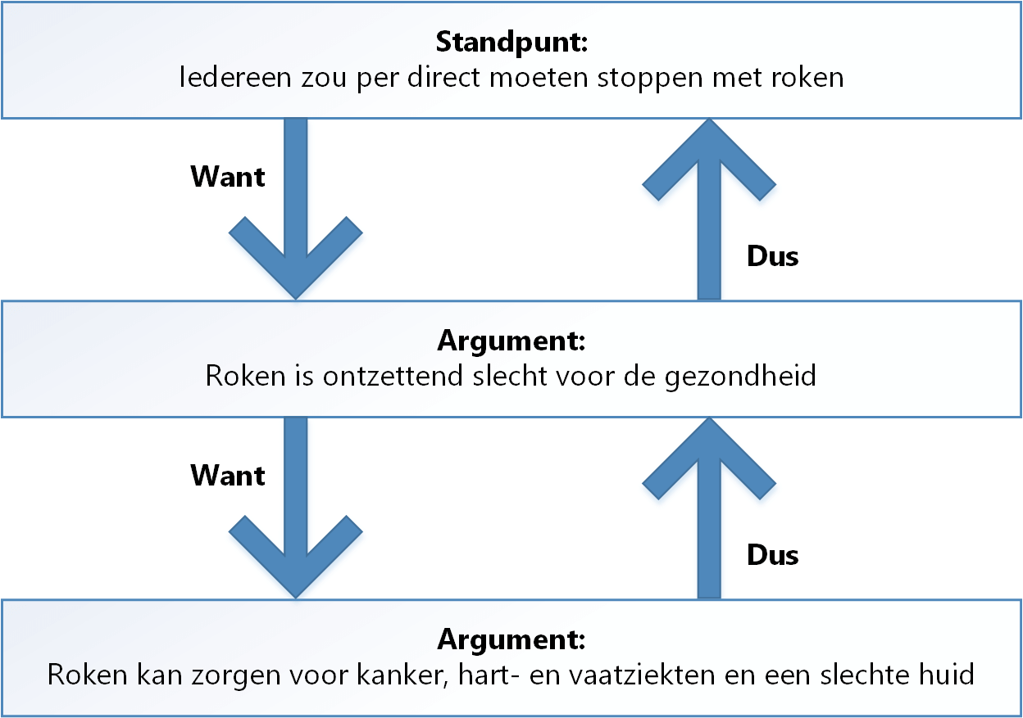

Sub argument

Hoofdargument